**ASSIGNMENT 19.1**

PROBLEM STATEMENT:

Dataset Link: <https://drive.google.com/drive/folders/0B_P3pWagdIrrTEVTVE1VWXI0YVk>

Using spark-sql, Find:

(i) What are the total numbers of gold medal winners every year.

Solutions:





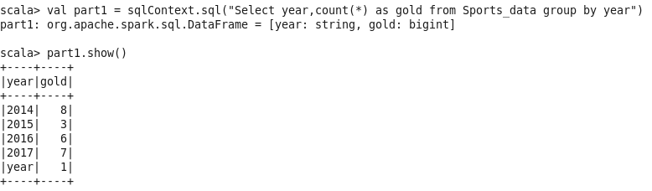

(ii) How many silver medals have been won by USA in each sport

Solutions:

